3.1a - f)

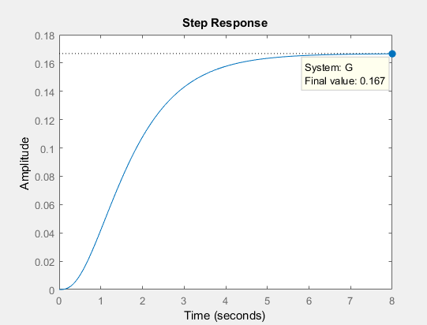

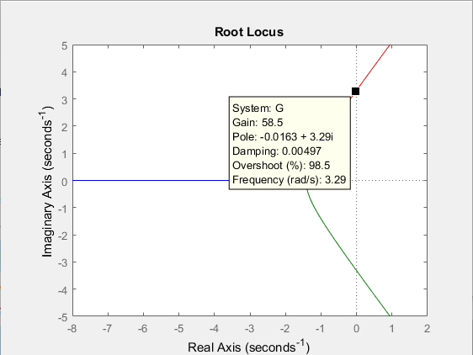

The point on the root loci is -0.0163 + 3.29j

Step info of G:

RiseTime: 2.7428

SettlingTime: 5.0039

SettlingMin: 0.1502

SettlingMax: 0.1665

Overshoot: 0

Undershoot: 0

Peak: 0.1665

PeakTime: 8.2586

Steady state error: 1 - SettlingMax = 0.1665

3.1 f)

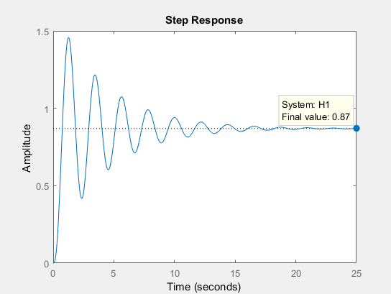

Step info of P Controller

RiseTime: 0.4368

SettlingTime: 15.6105

SettlingMin: 0.4176

SettlingMax: 1.4576

Overshoot: 67.6273

Undershoot: 0

Peak: 1.4576

PeakTime: 1.2687

Step info of G

RiseTime: 2.7428

SettlingTime: 5.0039

SettlingMin: 0.1502

SettlingMax: 0.1665

Overshoot: 0

Undershoot: 0

Peak: 0.1665

PeakTime: 8.2586

3.1 h)

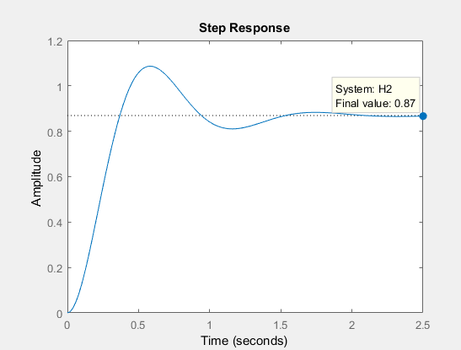

Step Info for PD Controller

RiseTime: 0.2494

SettlingTime: 1.4318

SettlingMin: 0.7921

SettlingMax: 1.0866

Overshoot: 24.9544

Undershoot: 0

Peak: 1.0866

PeakTime: 0.5905

3.1 i) The steady state error is decreased, the settling max is increased, settling time is decreased, overshoot is increased, rise time is decreased, system oscillation needs to be improved.

3.1 j)

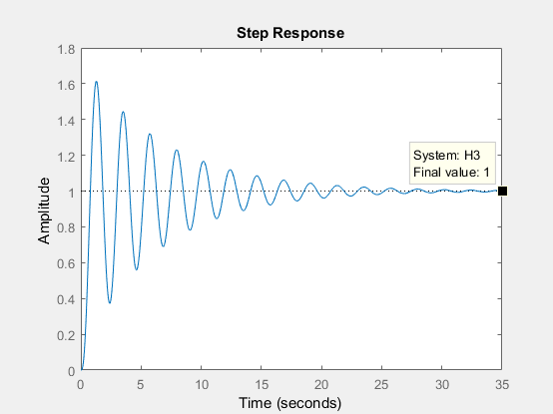

Step info of PI Controller:

RiseTime: 0.4593

SettlingTime: 23.6832

SettlingMin: 0.3725

SettlingMax: 1.6139

Overshoot: 61.3913

Undershoot: 0

Peak: 1.6139

PeakTime: 1.2975

3.1l)

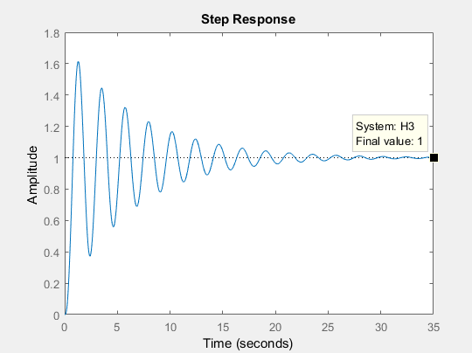

Kp = 10

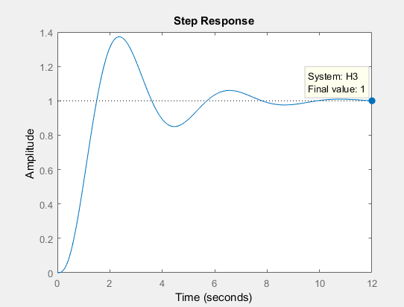

Step Info of PI Controller:

RiseTime: 0.9124

SettlingTime: 9.0786

SettlingMin: 0.8501

SettlingMax: 1.3727

Overshoot: 37.2709

Undershoot: 0

Peak: 1.3727

PeakTime: 2.3618

3.1m)

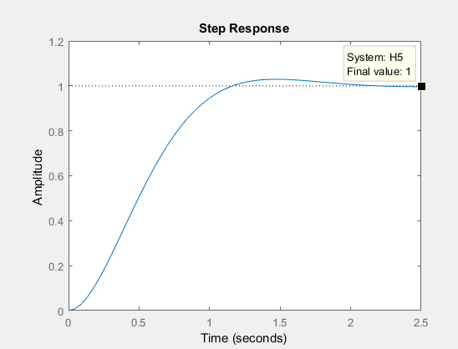

Step Info of PID Controller

RiseTime: 0.7352

SettlingTime: 1.7392

SettlingMin: 0.9035

SettlingMax: 1.0293

Overshoot: 2.9293

Undershoot: 0

Peak: 1.0293

PeakTime: 1.4858

Problem 4

|  |  |  |  |  |  |  |  |
| --- | --- | --- | --- | --- | --- | --- | --- |
| Type | Disturbance Rejection | Reference Tracking | Balanced | Rise Time | Settling Time | Overshoot | Steady State |
| P | 15.2 | 15.2 | 15.2 | 0.7154 | 5.3911 | 30.2416 | 0.717 |
| I | 1.84 | 1.84 | 1.84 | 4.0235 | 12.7324 | 7.4126 | 1 |
| PI | Kp = 7.59  Ki = 5.03 | Kp = 7.59  Ki = 5.03 | Kp = 7.59  Ki = 5.03 | 1.3383 | 6.0126 | 7.7325 | 1 |
| PD | Kp = 29.9  Kd = 14.8 | Kp = 29.9  Kd = 14.8 | Kp = 29.9  Kd = 14.8 | 0.3756 | 1.9573 | 18.5846 | 0.833 |
| PID | Kp = 12.5  Ki = 9.91  Kd = 3.97 | Kp = 12.5  Ki = 9.91  Kd = 3.97 | Kp = 12.5  Ki = 9.91  Kd = 3.97 | 1.0665 | 2.8508 | 4.5359 | 1 |

Problem 3

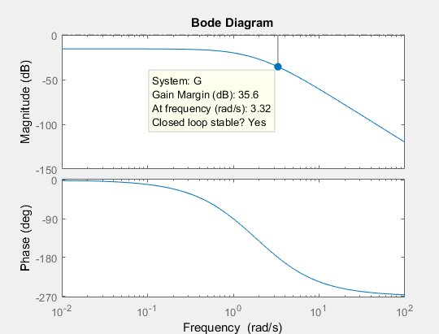

Ku = 10 ^ (35.6/20) = 60.26

Pu = 2*pi / (3.32) = 1.89

The point on the root loci is -0.0163 + 3.29j

Ku = 58.5

Pu = 2*pi / 3.29 = 1.91

|  |  |
| --- | --- |
| Type | Optimum Gain |
| P | Kp = 30.13 |
| PI | Kp = 27.12, Ki = 0.6439 |
| PID | Kp = 36.16, Ki = 1.058, Kd = 0.2363 |

d.

Controller Values:

Did not use Table 3 from lab instructions, rather used table provided on midterm as there was a discrepancy between them, that led to an output that was large and uncontrolled.

|  |  |
| --- | --- |
| Type | Optimum Gain |
| P | Kp = 30.13 |
| PI | Kp = 27.12, Ki = 1.592 |
| PID | Kp = 36.16, Ki =0.955, Kd = 0.2388 |

d.

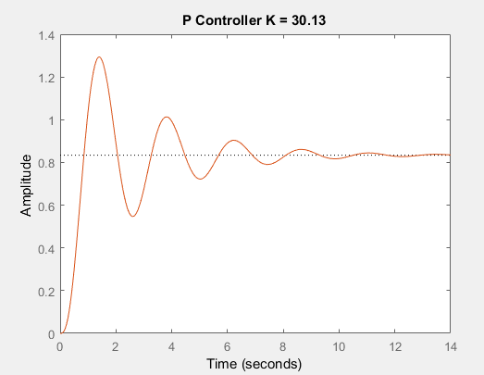

RiseTime: 0.5031

SettlingTime: 9.9155

SettlingMin: 0.5471

SettlingMax: 1.2935

Overshoot: 55.1110

Undershoot: 0

Peak: 1.2935

PeakTime: 1.3942